Core Equation
M(s)= Speaker+ Channel+Noise
$$M(s)=m+vy(s)+dz(s)+ux_{h}(s)$$
m=average human voice, vy(s)= speaker identity, uxh(s)= channel identity, dz(s)= residual speaker traits.
STEP 1 — SUPERVECTOR
Suppose speech features are:
$$x_{1},x_{2},x_{3},…$$
Each Gaussian has mean vector:
$$m_{c}$$
Concatenate all Gaussian means:
$$M=[m_{1},m_{2},m_{3},…,m_{C}]$$
This becomes:
supervector
LATENT VARIABLES
$$y(s)∼N(0,I) \\ x_{h}(s)∼N(0,I) \\ z(s)∼N(0,I)$$GAUSSIAN PRIOR
$$p(y)=N(0,I) \\ p(x)=N(0,I)$$

OBSERVATION MODEL
$$M_{h}(s)∼N(m+Vy+Dz+Ux,Σ)$$BAUM-WELCH STATISTICS
Zeroth-order stats
$$N_{c}=\sum_{t}{γ_{c}}(t)$$

First-order stats (o(t) is the feature vector at time t)
$$F_{c}=\sum_{t}{γ_{c}}(t)o_{t}$$

CENTERED FIRST-ORDER STATS
$$\tilde{F}=F-Nm$$

POSTERIOR PRECISION MATRIX
$$L=I+V^{T}Σ^{-1}NV$$

POSTERIOR MEAN
$$E[y]=L^{-1}V^{T}Σ^{-1}\tilde{F}$$

POSTERIOR COVARIANCE
$$Cov(y)=L^{-1}$$

COMPLETE DATA LOG-LIKELIHOOD
$$log⁡p(X,Y)=log⁡p(X∣Y)+log⁡p(Y)$$

GAUSSIAN LIKELIHOOD
$$p(X∣Y)∝exp⁡\left(-\frac{1}{2}(X-μ)^{T}Σ^{-1}(X-μ)\right)$$E-STEP
Compute:
$$E[y] \\ E[yy^{T}]$$
using current:
- $U$
- $V$
- $D$

M-STEP:
Take derivative of expected likelihood wrt $V$(to maximize likelihood):
$$\frac{∂Q}{∂V}=0$$
Result:
$$V=\left(\sum_{s}{F_{s}}E [ y_{s}]^{T}\right){\left(\sum_{s}{N_{s}}E[y_{s}y_{s}^{T}]\right)}^{-1}$$

M-STEP FOR $U$
Similarly:
$$U=\left(\sum_{h}{F_{h}}E [ x_{h}]^{T}\right){\left(\sum_{h}{N_{h}}E[x_{h}x_{h}^{T}]\right)}^{-1}$$

i-Vectors (2008)
Motivation
Before i-vectors:
GMM-UBM + MAP Adaptation
Each speaker was represented by thousands of GMM parameters.
Problem:
- Very high dimensional
- Difficult comparison
- Large storage
Idea:
Represent the entire utterance using one low-dimensional latent variable.

Pipeline
Audio
↓
MFCC
↓
UBM (GMM)
↓
Baum-Welch Statistics
↓
Factor Analysis
↓
i-vector
↓
PLDA

Speech – extract 13 MFCCs, each speech frame becomes 13 dimensional vector, for every frame we calculate $γ_{c}(t)$
UBM
Universal Background Model:
$$p(x_{t})=\sum_{c=1}^{C}{w_{c}}N(x_{t};μ_{c},Σ_{c})$$
where:
- $w_{c}$= mixture weight
- $μ_{c}$= Gaussian mean
- $Σ_{c}$= covariance

Posterior Responsibilities (prob that a frame belong to gaussian c)
$$γ_{c}(t)=P(c∣x_{t})$$
Ex: frame o(t) belongs 70% to gaussian1, 20% to gaussian2…

Zeroth-order Statistics
$$N_{c}=\sum_{t}{γ_{c}}(t)$$

First-order Statistics/ Centred Stats
$$F_{c}=\sum_{t}{γ_{c}}(t)(x_{t}-μ_{c})$$
Where exactly inside the gaussian frames are located

Total Variability Model
Supervector:
$$M=m+Tw$$
where:
- $m$= UBM mean supervector
- $T$= total variability matrix
- $w$= latent i-vector
- $N-matrix(occupancy stats)$

Assume prior: w ~ N(0,I) (Before observing speech, all I vectors assumed Gaussian around zero)
Estimate P(w/x) – which I vectors best explain the speech? Using Bayesian condition
Posterior becomes Gaussian
P(w/x)= N(E[w],L inverse)- Covariance
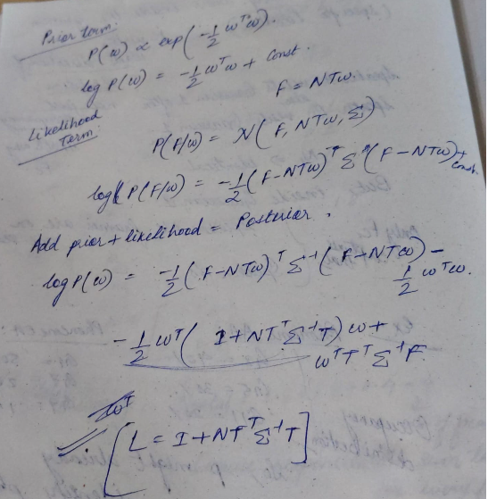
Posterior Covariance(Posterior precision matrix)
$$L=I+\sum_{c}{N_{c}}T_{c}^{T}Σ_{c}^{-1}T_{c}$$$T_{c}^{T}$ projects speech into latent variability space

Using EM Algo, we estimate random values for T initially,
Posterior Mean (i-vector)
$$w=L^{-1}\sum_{c}{T_{c}^{T}}Σ_{c}^{-1}F_{c}$$again we keep on updating the T-matrix till convergence.

Limitations
❌ Generative
❌ Linear
❌ EM training
❌ Depends heavily on MFCC

2. d-Vectors (2014)
Motivation
Researchers asked:
Why use GMMs when we have speaker labels?
Train a neural network directly.

Pipeline
MFCC
↓
DNN / LSTM
↓
Speaker Classifier
↓
Hidden Layer
↓
Average Pooling
↓
d-vector

Training
Input:
$$x_{t}$$
Output:
$$P({\text{Speaker}}_{k})$$
Softmax:
$$P(k)=\frac{e^{z_{k}}}{\sum_{j}{e^{z_{j}}}}$$

d-vector Extraction
Hidden layer:
$$h_{t}=DNN(x_{t})$$
Average:
$$d=\frac{1}{T}\sum_{t=1}^{T}{h_{t}}$$

Advantages
✅ End-to-end
✅ Nonlinear
✅ Discriminative

Limitation
Only mean pooling.
Two utterances can have identical means but different temporal distributions.

3. x-Vectors (2017)
Paper:
Snyder et al., ICASSP 2018

Main Idea
Improve d-vectors using:
TDNN
and
Statistics Pooling

Pipeline
MFCC
↓
TDNN
↓
Statistics Pooling
↓
Dense Layers
↓
Softmax
After training:
Remove Softmax
↓
x-vector

TDNN
Time Delay Neural Network(learns local temporal patterns)
Unlike normal DNN:
Frame t
TDNN sees:
t−2
t−1
t
t+1
t+2

Layer 1
Context:
$$\left[t-2,t-1,t,t+1,t+2\right]$$

Layer 2
Larger context.

Layer 5
Can see long-range speech patterns.

Statistics Pooling
Suppose TDNN output:
$$H=[h_{1},h_{2},…,h_{T}]$$
where
$$h_{t}∈R^{512}$$300X512- variable length-utterance, so we do pooling. Pooling converts TX512 into 1X512.

Mean (averages all the frames)
$$μ=\frac{1}{T}\sum_{t}{h_{t}}$$

Standard Deviation (captures variability)
$$σ=\sqrt{\frac{1}{T}\sum_{t}{(}h_{t}-μ)^{2}}$$

Concatenate:
$$\left[μ , σ\right]$$

This removes variable utterance length.

Why x-vectors outperform d-vectors
d-vector:
$$d=μ$$

x-vector:
$$x=[μ,σ]$$
Retains variability information. 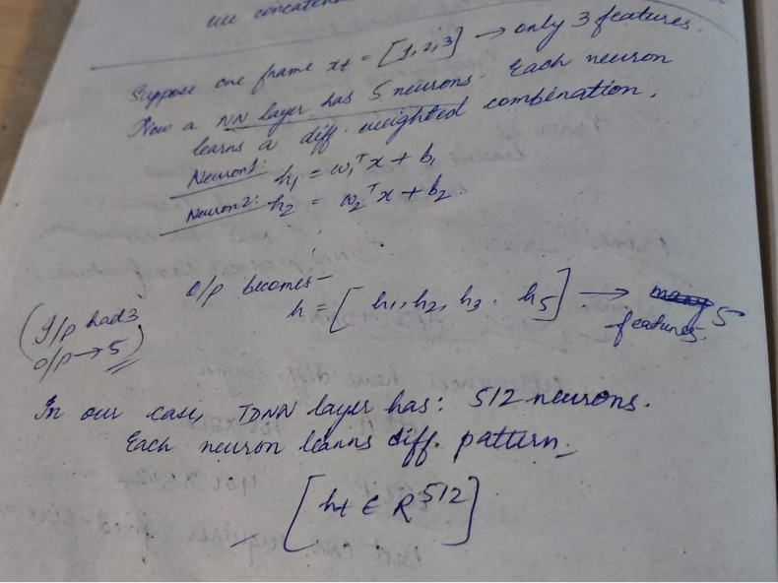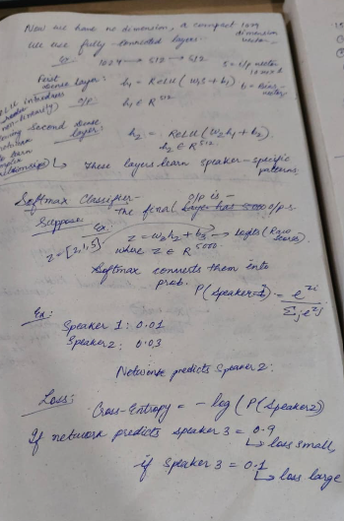

4. ECAPA-TDNN (2020)
Paper:
Emphasized Channel Attention, Propagation and Aggregation in TDNN

Motivation
x-vectors had some issues- very small temporal context, only looks at limited frames, only considers the last layer, discards the others which ca be important, considers all fames/channels if equal imp/weights, but some may contain noise(can be ignored).

Pipeline
Fbank
↓
SE-Res2Blocks
↓
MFA
↓
Attentive Statistics Pooling
↓
FC
↓
ECAPA Embedding

SE Block
Squeeze-and-Excitation
Question:
Which channels are important? 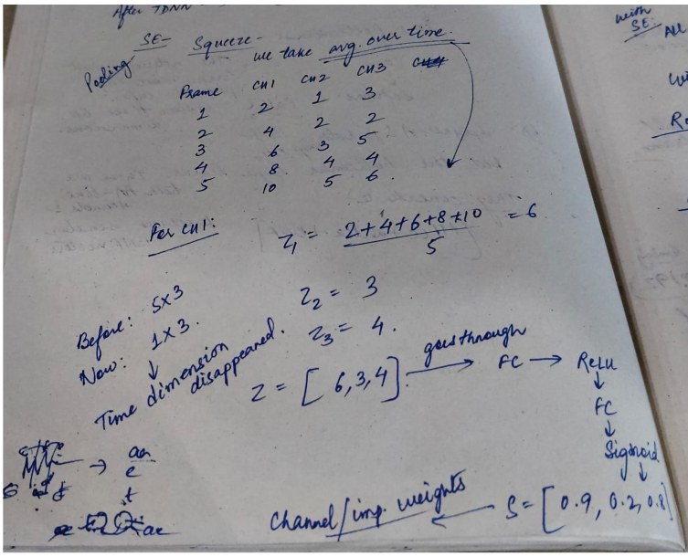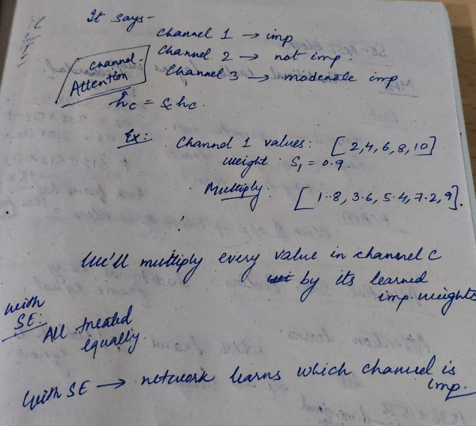

Res2Net
Instead of one convolution:
Split channels:
512
↓
8 grps, each grp has 64 channels.
Grp1- learns short-context, grp2 learns medium context, grp3 learns long-context
Allows multiple temporal scales.

MFA (traditionally earlier layers were discarded)
Combine:
Layer 3 B1= 300X512
Layer 4 B2= 300X512
Layer 5 B3= 300X512
512+512+512=1536 (each frame has 1536 dimensions/features)
instead of using only the final layer.

Attentive Statistics Pooling(earlier every frame equal) Attention learns which frame important?
Instead of:
$$μ=\frac{1}{T}∑h_{t}$$
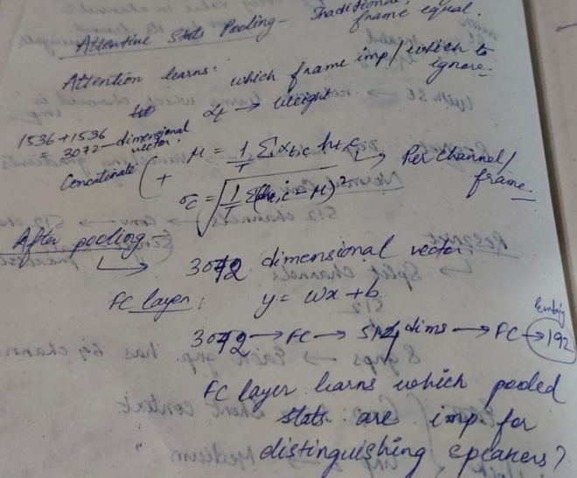
learn attention:
$$α_{t}=softmax(v^{T}tanh(Wh_{t}+b))$$

Weighted mean:
$$μ=\sum_{t}{α_{t}}h_{t}$$

Weighted std:
$$σ=\sqrt{\sum_{t}{α_{t}}(h_{t}-μ)^{2}}$$

5. R-Vectors (2019)
Paper:
R-vectors: Room Embeddings

Key Insight
x-vector architecture is generic.
Instead of speaker classes:
Speaker A
Speaker B
Speaker C
use
Room 1
Room 2
Room 3

Room Simulator (mathematically create a room using acoustic physics)
Generate:
Length
Width
Height
Mic Position
Speaker Position
wall Absorption

Compute:
$$h(t)$$
Room Impulse Response (RIR).

Reverberant Speech
Clean speech:
$$x(t)$$
RIR:
$$h(t)$$
Convolution:
$$y(t)=x(t)*h(t)$$

Meaning:
Speech recorded inside that room.
VAD(Voice Activity Detection) – remove silence (distinguish btw speech and non-speech frames)

Training
Room labels:
Room 1 → Class 1
Room 2 → Class 2
...
Room 30000 → Class 30000

Softmax:
$$P(i)=\frac{e^{z_{i}}}{\sum_{j}{e^{z_{j}}}}$$

Example:
Room 57 = 0.92
Room 12 = 0.01
Room 999 = 0.00
Meaning:
Network thinks there is 92% probability that the utterance originated from Room 57.

After training:
Remove Softmax.
Keep hidden layer:
$$r$$
This becomes the R-vector.

Evolution Summary
Method | Main Idea | Pooling | Learns
i-vector | Factor Analysis | Statistics (Nc,Fc) | Speaker
d-vector | DNN Classification | Mean | Speaker
x-vector | TDNN Classification | Mean + Std | Speaker
ECAPA | Attention + Res2Net | Attentive Mean + Std | Better Speaker
R-vector | x-vector architecture | Statistics Pooling | Room
